# Semester Project Phase 1 – Group B

## Group Members

* Michael Ng: Team Leader
* Emily Ervin: Document Manager
* Preston Ware: Lead Developer
* Aaron Henderson: Lead Designer
* The Quality Manager is shared equally across the team.
* Our team communicates using Discord. We also have set up a GitHub repository for later use.

## Client Information

* Client: Lindsay Roberts
* Business: Twisted Vinyl
* Lindsay Roberts is the owner of a small family business named “Twisted Vinyl”.
* The company mainly sells decorated T-Shirts, but also do other types of decorations such as Sublimination Printing, Vinyl decals on car windows, home decorations, etc.

Business Card: 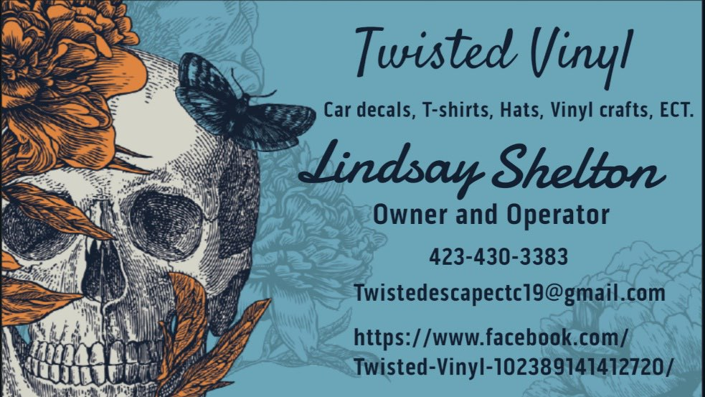

Logo: 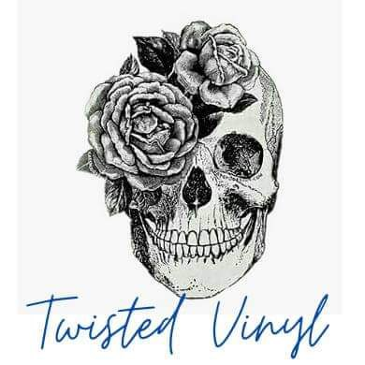

## Website Details

* The webpages we will include (at the moment) are:
  + Homepage
    - This page will act as the main page, giving a brief overview of the company and what it does.
    - This page includes the Customer Reviews and Comments alongside featured products.
  + About Us
    - This page talks about the founding of the company, as well as its owner’s reasons for starting the company and their background.
  + Contact Us
    - This page can be used if a consumer wants to get in touch with the owner.
    - Customers can order special appointments with the owners for products like car window vinyl.
  + Gallery
    - This page is mainly used to show off pictures of what each finished product may look like.
    - This page may also contain customer reviews of each product.
  + Shopping Page
    - This page allows the consumer to buy T-Shirts and other products from the website.
* The theme of the website, as requested by Lindsay, will be light blue, much like the color on her business card.

## Site Mission Statement

* *To make sure our customers are happy with the finished design.*
* [Side note: Twisted Vinyl does not have a formal motto as of the 2nd Interview.]

## Anticipated Key Components

* Homepage
* Search Bar (To search products or other items. A must have, as requested by Lindsay.)
* Products and Gallery page.
* Reviews and Comments about Products
* Options that allow the user to change the color of a product while browsing.

## Interviews and Descriptions

* Interview 1 (Friday, February 12, 2021 – 11:30AM to 12:00PM): Introductions with the client, Lindsay, and some initial questions about the project, webpage, and business were asked. We were introduced to the business and what it does.
* Interview 2 (Wednesday, February 17, 2021 – 10:00PM – 10:10PM): Follow-up questions with Lindsay were asked.

## Typical Customer Attributes (Group A)

Group A consists of younger people aged 10 – 24 years old. Their shared interests include memes and videogames.

* Age Ranges: For this group, 10 – 24 years old.
* Dominant Gender: There is no dominant gender in this age group.
* Level of Education: Depending on age, may range from Middle School to some/full college.
* Occupation: Most people in this group may be attending school/college and/or working part-time jobs.
* Hobbies and Interests: Primarily, Memes, Videogames, or anything that is trending.
* Web/Computer Experience Level: Mediocre, depending on how often they (are allowed) to use a computer or internet device.
* Type of equipment used: A computer or tablet may be the most common choice in this age group.
* Group Relationship with Twisted Vinyl: May be related with Group B. Likely the offspring of a friend or a close friend of Lindsay.
* How this group knows about Twisted Vinyl: From parents or friends.

## Typical Customer Attributes (Group B)

Group B consists of adults aged 25 – 40 years old. Their shared interest is parenting.

* Age Ranges: For this group, 25 – 40 years old.
* Dominant Gender: Neither gender is dominant but may lean closer towards Females (Many of her customers from this age group are her friends).
* Level of Education: Most clients have full high school education, with some having taken college.
* Occupation: Varies across this group (There is no dominant job or job area).
* Hobbies and Interests: Parenting and being with Family.
* Web/Computer Experience Level: Little to a lot, depending on the individual.
* Type of equipment used: Mainly smartphone but may also use a tablet or computer.
* Group Relationship with Twisted Vinyl: Typically, close friends or acquaintances with Lindsay.
* How this group knows about Twisted Vinyl: Referral or being friends with Lindsay.

## Personas

### Michael Ng: Justin Time (Group A Male)

Justin Time is a College Sophomore, and likes to tell jokes and hang out with friends. Impairments: Colorblind.


### Michael Ng: Mina Time (Group B Female)

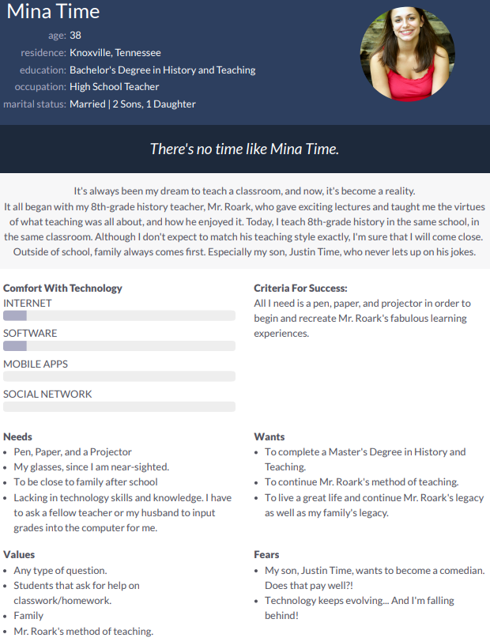

### Preston Ware: Suzi Blevins (Group A Female)

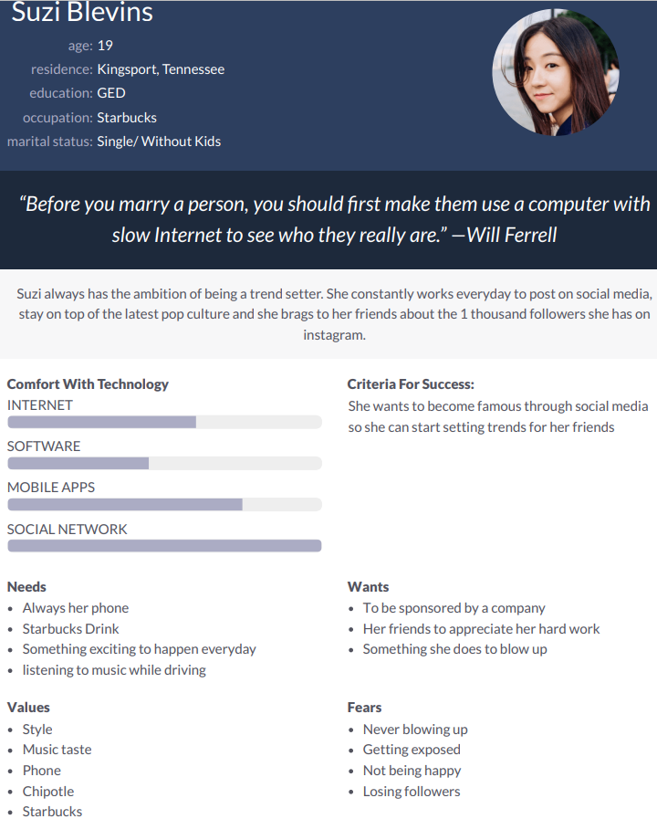

### Preston Ware: Maleko Obama (Group B Male)

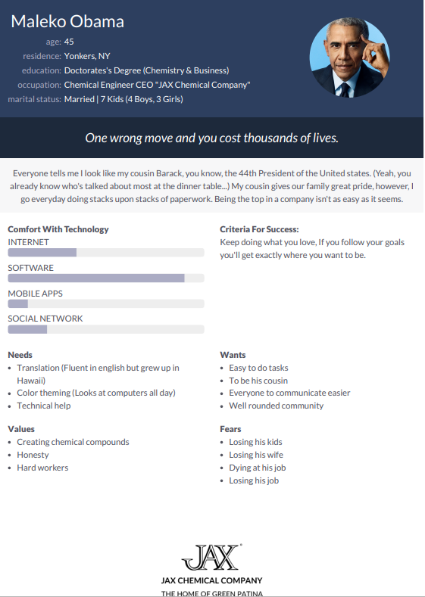

### Aaron Henderson: Todd Miller (Group B Male)

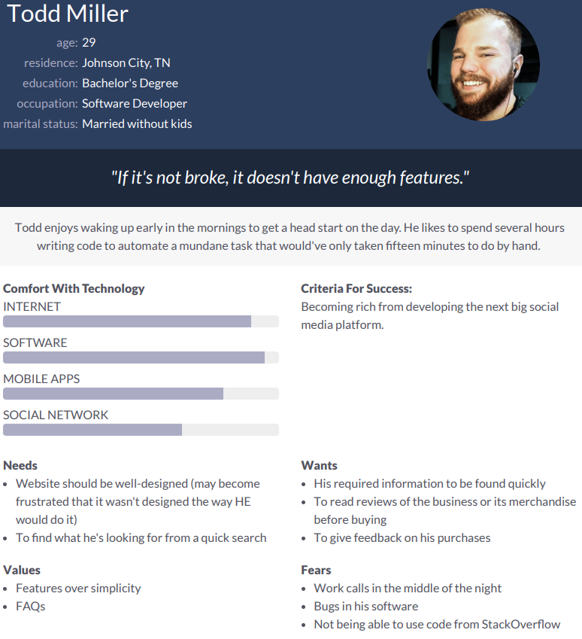

### Aaron Henderson: Tucker Edwards (Group A Male)

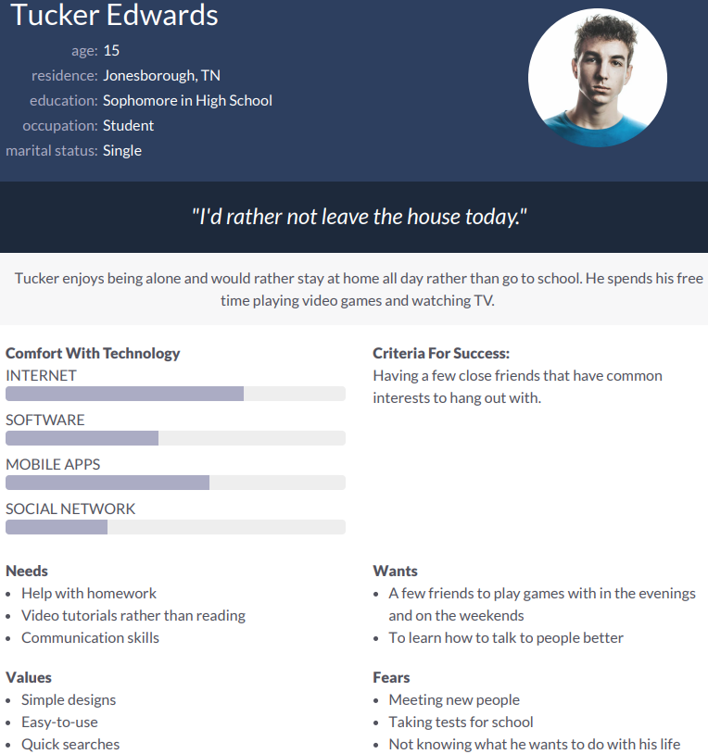

### Emily Ervin: Courtney Jones (Group B Female)

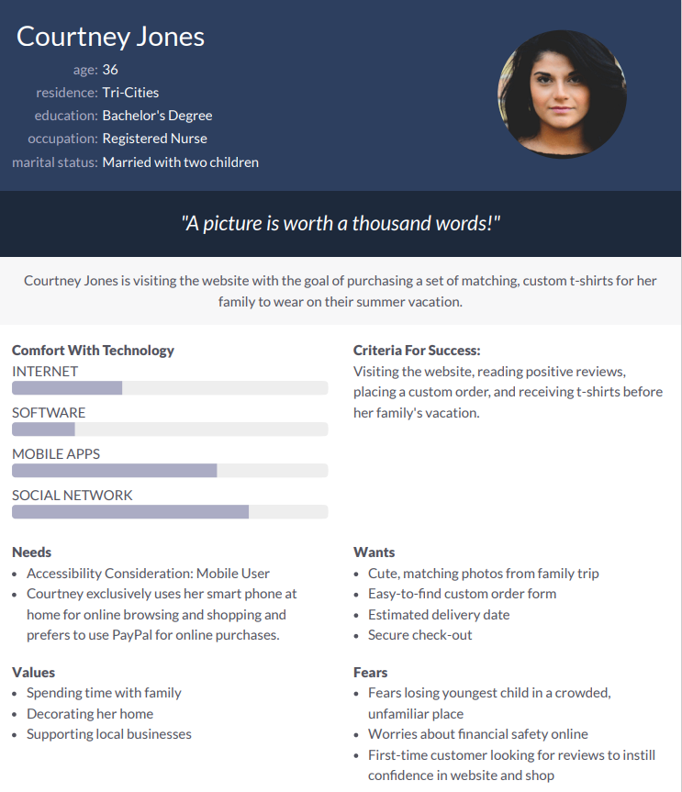

### Emily Ervin: Kenzie King (Group A Female)

